Southeast Michigan Bromeliad Society Newsletter May-June 2016
The May meeting will take place on Saturday, May 21 at 2 pm. It will be hosted at the home of Paul and Karen Wingert, 27276 Edgemoor, Farmington Hills, MI 48334. Paul’s cell phone is 248-798-4139 if you need to contact him on the meeting day. Plant orders are arriving from Florida and California. If you pre-ordered anything, they will be sorted and ready for pick up. For those who didn’t order anything in advance, there will be plenty of “extra” plants to tempt you. We have 25 “Grower’s Choice” plants coming from Michael Kiehl, and plenty of extra Tillandsias, including many species and hybrids that have not been available here before. Even if you’re not inclined to add any plants to your collection at this time, there will be plenty of new and exciting things to see! Some special instructions for those attending the meeting. As usual, go up the steps behind the house. The Wingert’s now have a fenced yard (for the dogs!) Come through the latched gate, and take care that it is securely closed behind you. There is also a robin’s nest in a honeysuckle bush along the path up to the shadehouse. Count on the poor, nervous mommy robin to take flight as you go by!
As usual, there are many of Paul’s more recent hybrids coming into flower. Several of the 2-3 year old Neoregelia and Vriesea seedlings are showing great promise, even at a young age!
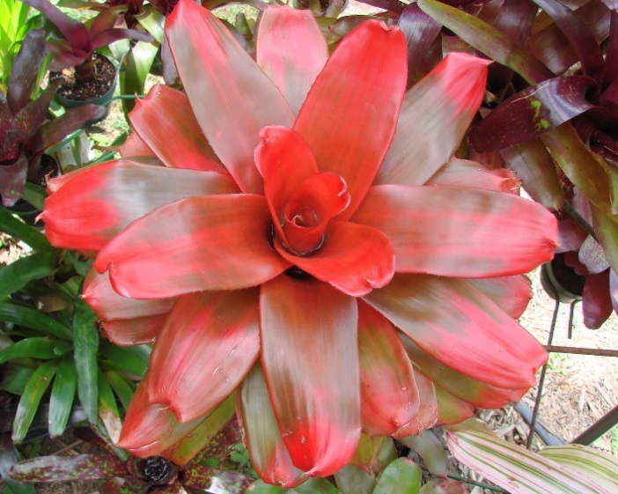
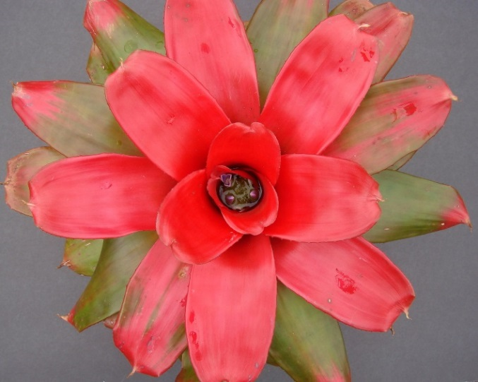
This hybrid- Neoregelia [(Pink Sensation x sib.) x Puerto Rico] x 'Royal Cordovan'- started blooming in early April. It took several years from seed to flower, as it stacked many layers of leaves. This is an uncommon trait in Neoregelias growing at our northerly latitude. It is hoped that future generations will maintain that trait. The second photo is same plant as it appeared from last August. Even without flowering, it has been an alluring plant.
The following photo shows two selections from a grex of Neoregelia ‘Small Wonder’ x ‘Treasure Chest. Note the subtle differences in coloration, plant shape, and width of leaves. Colors are continuing to intensify as the plants approach first flower. There’s a reasonably good chance that one, or both, might be in bloom in time for the May meeting.
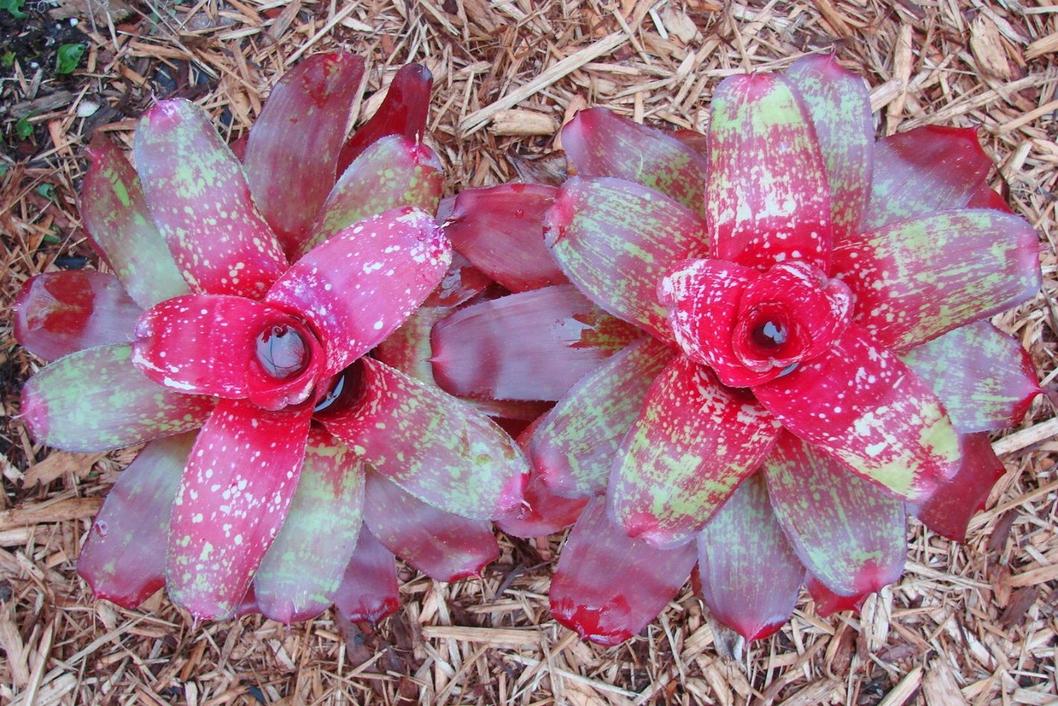

Our thoughts and prayers are with Pen Goff as he recovers from surgery. It is hoped that the outcome will restore some or most of his former mobility! Pen is convalescing for the next week or two at Fox Run in Novi. Best wishes that physical therapy proves very productive!
There will be no meeting during the month of June. The World Bromeliad Conference will be taking place in Houston, Texas from June 13-19 (in conflict with our regular meeting time). For those who might be interested in attending the conference, the date has been extended for pre-registration. Check out WBC Houston 2016 for more information. Details of the July meeting will follow in the next newsletter.
Growing variegated plants from seed- by Paul Wingert.
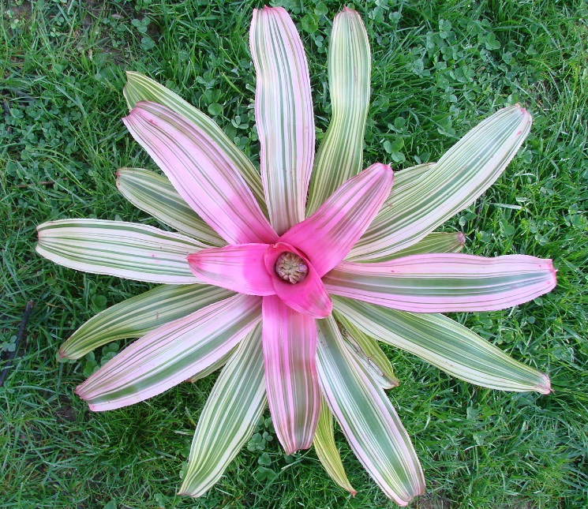
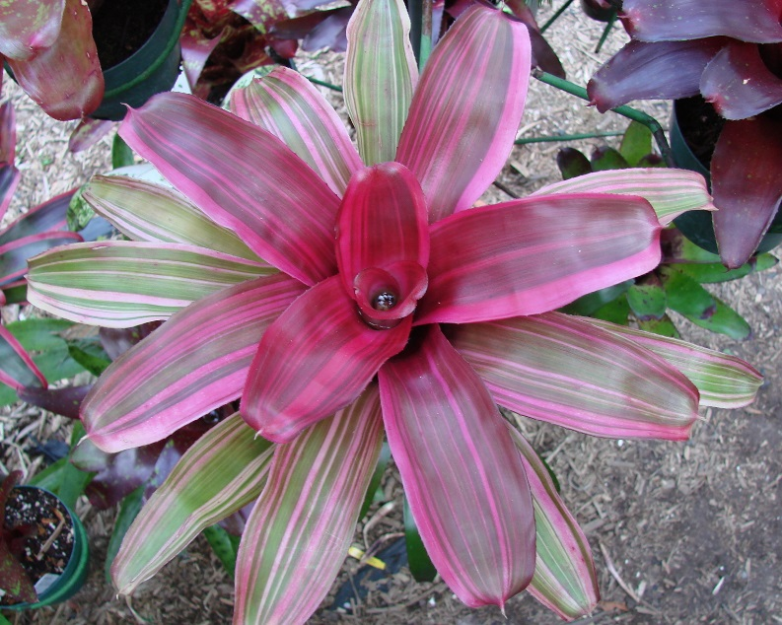
There is a certain fascination with variegated plants, and with finding “transmitter” plants which will produce new, variegated hybrids. Several years ago, Paul acquired a plant recommended by Brian Weber (at Tropiflora nursey in Sarasota, FL) which had come from the acclaimed bromeliad hybridizing guru Chester Skotak. One crop of seed produced a good proportion of variegated seedlings, and those began to bloom last summer. The plant pictured at left was the first to flower. The photo was taken shortly before first bloom last August. It’s a quite a pretty plant, with good color and decent variegation. If there is a drawback to growing variegated plants from seed, it is that they can be very unstable. Patience is a must! It often takes growing several generations of pups to ascertain whether a selected clone will maintain “stable” variegation. Some plants may show great promise in the seedling generation, only to produce a preponderance of albino pups or non-variegated (plain green or “NOVAR”) pups. Meanwhile, there is a quest to find future “transmitter” plants. The best indicator for the trait is to observe the sepals of a flowering plant. Sepals which are solid green will tend to produce “green” leaved seedlings. All white sepals will invariably produce “albino” seedlings, which will quickly die. Sepals which are white, “streaked” with green, are the best indicator that a flower will produce seed that will in turn produce variegated seedlings. The plant pictured (at right) began blooming in early May. Again, a reasonably pretty plant on its own, though the plan is to use it to create more new and interesting variegated hybrids! Some of the flowers have had all white sepals, but several have been the “streaked” sepals that one looks for. So there is optimism that this will turn out to be a good variegate transmitter!
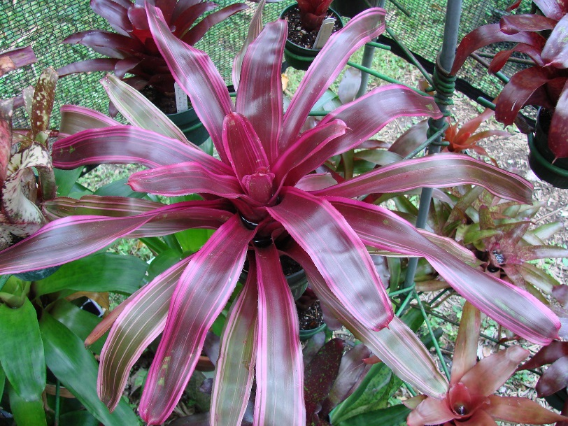
Here is a sampling of some of the other variegated seedlings that were produced in that original cross. There is hope that more than one will be useful in creating even more beautiful variegated hybrids in the future!
